

**Brexit and the pound**

Speech given by

Ben Broadbent, Deputy Governor Monetary Policy

Imperial College, London 23 March 2017

I’d like to thank Matt Corder, Chris Salmon, Michael Saunders, Greg Thwaites and Anthony Veal, along with other colleagues, for their helpful comments and assistance. I reserve particular thanks for my Economic Advisor Alina Barnett.

# Introduction and summary

The vote to leave the EU led to a big drop in sterling’s exchange rate. One consequence is a rise in import prices and a squeeze on households’ real income. We may already be seeing the impact of that squeeze on retail spending, which in real terms fell quite sharply around the turn of the year.

While it’s hit the income of households, however, the depreciation has come as a boon for many exporters. In sterling terms goods export prices rose 12% through the course of last year. This will significantly have boosted exporters’ profitability and with it the incentive to invest in extra capacity.

In general, it’s not really right – not enough at least – to think about the impact of a change in the exchange rate in isolation. Asset prices are volatile in the short run, sometimes inexplicably so. But over time they tend to move for a reason. They’re driven by deeper things that can have important effects of their own. To get the full picture you need to take both into account, not just the partial impact of a change in the exchange rate but those of its underlying drivers as well.

Take sterling’s fall in 2008 and 2009. One plausible explanation was that the financial sector is more important for the UK – notably its exports and the government’s tax receipts – than for other countries. So its economy and public finances were more vulnerable to the global financial crisis. The depreciation helped to cushion these effects but it wasn’t enough to outweigh them. The downturn was no less severe here than elsewhere, notwithstanding sterling’s fall.

Sterling’s more recent decline was clearly prompted by the referendum result. It also seems likely that the foreign exchange market has decided the consequences are negative. The most plausible explanation for the depreciation is that, in the eyes of the market, leaving the EU will make exporting harder and more costly. To help compensate the currency needs to be cheaper.

There are many important differences with 2008/09, of course. One is this: Brexit hasn’t happened yet. Back then sterling’s fall happened alongside its cause. On this occasion the depreciation reflects beliefs about a change in the UK’s future trading arrangements, but it’s acting on an economy where those arrangements are for the time being unchanged. The result – higher prices and profits but unchanged rules and costs – represents something of a sweet spot for exporters and businesses that compete with imports.

How they respond is one important determination of economic growth this year. Usually, one of the more positive aspects of an exchange-rate depreciation is that, by raising their profitability, it encourages the expansion of firms in the tradable sector. With the world economy in better health than for some time, there is certainty every incentive to do that today. On this occasion that response might be more muted than usual, however, because it’s not clear how long the sweet spot will last. If the currency market is right the UK’s future trading relationships will be less favourable; if it’s too pessimistic sterling is likely to rebound. Either

way, future returns in the tradable sector may not be as healthy as they are right now. This may act as something of a deterrent to longer-term, sunk-cost investments in that sector.

In what follows I’ll begin by looking at sterling and what economics has to say about its reaction to the referendum result. I’ll then say something about how depreciations work in small open economies, in particular their impact on profitability and investment in the tradable sector. There’s a short concluding section.

# Sterling’s response to the EU referendum: some exchange-rate economics

So let’s begin with the depreciation and its proximate cause, the outcome of referendum. The link between the two was clear long before the vote itself. In the months leading up to June 23 there was a tight correlation between the value of the currency and the perceived likelihood of a “remain” vote (Chart 1).

|  |  |
| --- | --- |
| That’s why the MPC, in conditioning its May 2016 forecasts on that outcome, assumed a higher path for the exchange rate. It’s also why the Committee suggested there might be a “sharp correction” in sterling’s value in the event of a leave vote. And in the event that’s what we got. On June 23 and 24 sterling fell further against the dollar than over any two-day period since the devaluation of 1967.  You didn’t need any economics to make this prediction – the relationship in in Chart 1 was enough. But you probably do need some economics if you want to understand why the currency reacted this way. While we don’t know  precisely what’s in the collective mind of the | **Chart 1: Sterling sensitive to expected result well before the referendum itself** |
| Source: Bloomberg, Thomson Reuters Datastream, Betfair |

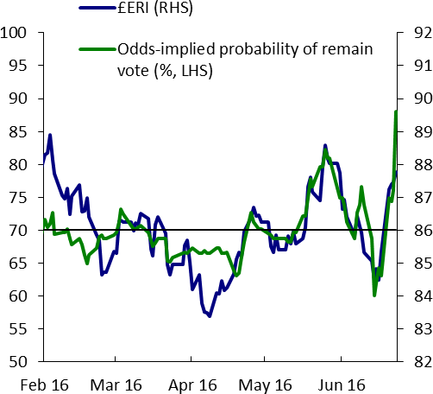foreign exchange market, in my view there are two broad possibilities: Brexit is expected either to weaken domestic demand or raise the cost of exporting.

To understand these effects remember first what the real exchange rate is: the relative price of consumption here compared with that in our trading partners1.

Suppose you split consumption into stuff that can only be produced domestically (“non-tradables” like homes or haircuts) and things that can also be imported from abroad (“tradables” such as holidays and cars). This distinction is important because you’d expect prices of traded goods and services to move reasonably closely across countries (I’ll return to this point later). If so, it turns out you can re-express the real exchange rate in terms of another relative price, that of non-traded to traded output2:

𝜀 ≈ 𝑝𝑁𝑇⁄𝑝

𝑇

[1]

So when things happen that push up this relative price, whether on the demand or the supply side of an economy, the real exchange rate will tend to move in the same direction.

Take domestic demand first. The material distinction between non-traded and tradable output is that, whereas the first can only be supplied domestically, the second is also produced elsewhere: its overall supply is more “elastic”. New houses can only be built by domestically located firms; cars are made everywhere.

So even a general increase in domestic demand will put relatively more pressure on the resources used to produce non-tradables as their global supply is more limited. As a result their relative price will tend to rise in domestically led expansions and to fall in contractions. This is illustrated in an extremely stylised way in Chart 2. You can think of the appreciation, in this case, as the economy’s way of tempering the effects on relative demand and, at the same time, encouraging resources to move where they’re needed. If domestic demand strengthens, the resulting rise in the exchange rate reduces returns in the tradable sector and raises them in the non-traded sector, drawing investment from the first to the second.3

This isn’t just theory. We know, for example, that fiscal expansions tend to be associated with an appreciating exchange rate4. More generally real exchange rates tend to be pro-cyclical. Chart 3 plots the relationship for the UK, with both lines – sterling’s real exchange rate and domestic demand growth – plotted

1 I’m interested here in the real forces driving the exchange rate. The nominal rate, e = εP*/P, where P* and P are price levels at home and abroad respectively, also depends on relative inflation rates. And in the shorter run, when those prices are sticky, monetary events can and do affect real exchange rates. But over time, the real exchange rate depends more on non-monetary things. And in this particular instance, sterling’s fall had essentially nothing to do with differences in monetary policy (as measured, for instance, by shifts in relative short-term interest rates). Note too that, judging by the behaviour of forward inflation rates, financial markets too consider this to be a real phenomenon: five years ahead, the expected value of eP/P* is around 16% lower than it was at the start of 2016.

2 This ratio then has to be divided by the same ratio in our trading partners. Obviously for every domestic shock described here, the

exchange rate is affected symmetrically, and in the opposite direction by the same phenomenon in the rest of the world.

3 The ease with which this happens is what determines the slope of the supply curve in Charts 2 and 4. In the limit, if resources can

move seamlessly and costlessly between sectors, the supply curve is flat. But this reallocation could take a long time. Empirically, over cyclical horizons, the correlation between exchange rates and demand disturbances is clear.

4 Arguably, the recent appreciation of the US dollar owes something to the expectation that the incoming administration will loosen fiscal policy.

as four-year moving averages. The graph also illustrates quite how weak the currency is at the moment (the green dot on the right-hand side) given the recent robustness of domestic demand growth (the blue dot).

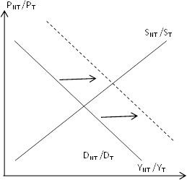Among other things this framework has important implications for the link between exchange rates and “imbalances”. The UK has periodically experienced episodes where the exchange rate is strong, the external balance deteriorates and, on the production side of the economy, the traded sector gets “crowded out”. One often hears that all this is the “consequence” of an “over-valued exchange rate”, as if that were some arbitrary, unexplainable thing.

|  |  |
| --- | --- |
| **Chart 2: Stronger domestic demand tends to push up the exchange rate** | **Chart 3: UK data bear this out** |
|  | Source: ONS and Thomson Reuters Datastream |

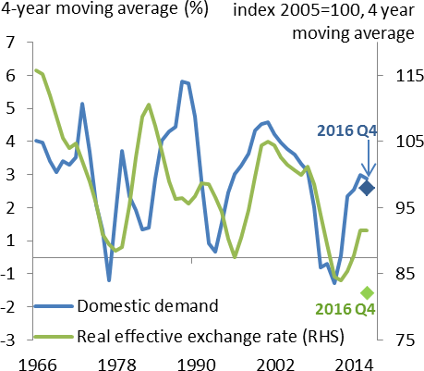But in these situations the exchange rate is more symptom than cause: the underlying driver is relatively strong growth in domestic demand5. And it’s this that jointly pushes up both the value of currency and the trade deficit6. Indeed I think this helps to explain why sterling appreciated so strongly after 2012 (and until last year): relative to their respective incomes, domestic demand grew much more strongly in the UK than among its main trading partners in continental Europe.

There’s a limit to the duration of financial deficits, at an aggregate as well as an individual level. It was always unlikely that the UK could finance a 5%-of-GDP current account deficit indefinitely and the market would presumably have anticipated a closure at some point, partly via weaker growth of domestic demand. But one possibility, regarding sterling’s recent behaviour, is that the foreign exchange market believes that leaving the EU will hasten the correction of these imbalances. If, for as long as it lasts, financing the deficit

5 The word “relatively” is important here – what matters is the behaviour of domestic demand compared with that in other countries. If demand weakens in other countries the home country’s exchange rate will still appreciate even if nothing happens to domestic savings rates.

6 For a thorough treatment of the relationship between imbalances and the exchange rate – and specifically the chain of causation running from the former to the latter – see Obstfeld and Rogoff (2000), Obstfeld and Rogoff (2007).

relies on “the kindness of strangers” (as the Governor once described it) perhaps the foreign exchange market thinks those strangers will be less generous to a UK outside the EU. International capital markets might require a higher premium for sterling finance. If so, this would slow the growth of domestic demand that much earlier, accelerate a rebalancing of the economy and depress the fair value of the exchange rate7.

While possible in principle, I’m not convinced this is the main explanation for sterling’s reaction to the referendum result. The currency has remained weak even in the face of robust consumption growth since that date. And if the foreign exchange market had anticipated a higher cost of finance for sterling borrowers after Brexit you’d probably have seen the same expectation in other financial markets – a steeper yield curve, perhaps, or higher premia in UK banks’ funding markets. That hasn’t really happened.

|  |  |
| --- | --- |
| **Chart 4: Weaker productivity in tradable sector depresses the exchange rate**  PNT /PT  SNT /ST | **Chart 5: Supported by cross-country evidence** |
| DNT /DT  YNT /YT | Source: Penn World Table |

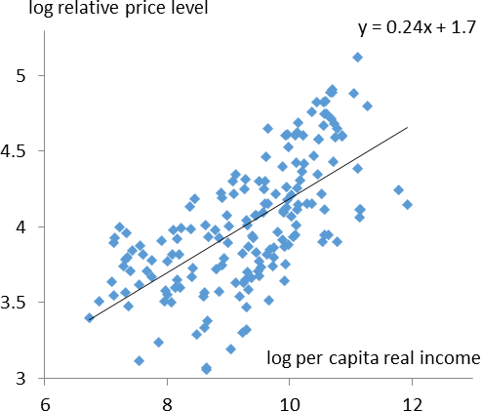A more likely channel, to my mind, involves expected supply. Go back to that relationship in [1] and imagine now that something happens to push up the cost of producing or selling tradable goods. Perhaps productivity in that sector grows less rapidly (relative to that in our trading partners)8. Or perhaps tariff and/or non-tariff barriers are imposed on international trade. Either way, if the relative cost of producing or selling tradable output goes up then so must its relative price (Chart 49). In effect, the currency falls to help absorb these costs. In doing so it spreads them throughout the economy: even those in the non-traded sector have to work longer to buy the same quantum of imports.

7 Sometimes this point is expressed in terms of the “sustainable” current account deficit but it amounts to the same thing.

8 Cost is inversely related to productivity.

9 Note that a contraction in tradable productivity, which is the denominator in the SNT/ST curve, shifts it to the right.

There is ample empirical evidence of this channel in the data. Chart 5, for example, is a cross-country plot of relative price levels (the real exchange rate) against per-capita income. The latter is determined by

whole-economy productivity. But much of the variation in aggregate productivity, across countries as well as over time, is in the tradable sector specifically. So the correlation is reasonably persuasive evidence of the link between tradables productivity and exchange rates10. And it’s quite possible that this is what lies behind sterling’s reaction to the referendum. Foreign exchange markets may believe that exiting the EU will in some way raise the cost of exporting – either directly, via the erection of barriers of one sort or another, or by depressing inward investment and productivity in the tradable sector (relative to that in other countries).

# What does the weaker currency do in the meantime? Some more exchange-rate economics

I should emphasise at this point that what I’m musing about here are the implicit beliefs of the foreign exchange market. The specific question is why that market thinks the long-term consequences of leaving the EU warrant a lower sterling exchange rate. For its part the MPC has no particular expectation about the forthcoming negotiations. The currency market could turn out to have been too pessimistic.

Two things are clear, however. First, if the market has misjudged the risks – if the UK emerges from this as open an economy as it is today, or more so – one imagines the exchange rate will re-appreciate, all else equal. I’ll come back to the significance of this point later on.

Second, the weaker exchange rate is acting on an economy whose trading relationships are for the time being quite unchanged. As yet Brexit has done nothing directly to affect the UK’s openness because Brexit hasn’t happened.

The MPC is always keen to caution against treating a change in asset prices as some independent, “exogenous” event, without considering its underlying cause. This case is a bit special, however: in this instance the cause has yet to occur. We’ve had the reaction in asset prices well ahead of the event. In that sense it’s more independent than usual.

And what’s striking about this is that economists usually view independent depreciations in the exchange rate as expansionary rather than contractionary. Yes, they dent real household incomes and therefore consumer spending. But the usual view is that this negative effect is compensated, indeed outweighed, by positive effects on other areas of spending, net exports and investment. With the additional tailwind of a strengthening world economy you might expect most forecasters to have predicted faster economic growth following sterling’s decline. Yet the opposite is true: after 2% through 2016 (in the year to Q4), the consensus forecast is that UK GDP growth will slow to 1.2% through this year.

10 In economics the impact on the exchange rate of variations in tradable versus non-tradable productivity is known as the “Balassa-Samuelson” effect (Samuelson (1964); for a survey of the evidence see Egert et al (2006)).

I want to ask why this is. Why do forecasters think the more negative effects of sterling’s fall will predominate

– what impediment might there be to its more positive effects? To do so it’s worth taking a closer look at how depreciations actually work.

The view one often hears is that they make UK output cheaper in foreign currency terms, encouraging extra demand from overseas. I’m not sure that’s quite right.

I said earlier that economists often make the approximation that prices of tradable goods and services are the same in all countries (measured in some common currency). This makes intuitive sense when you think of an area like commodities. For example, you would not expect sterling’s fall to reduce the dollar price of North Sea oil or the euro price of UK-produced wheat. Those are determined largely in global markets. What happens instead is that their prices go up in sterling terms. And if there is a response of net export volumes it comes about largely because the rise in prices directly boosts the profitability of UK-based production.

Whether we’re talking about firms that export or those that compete with imports, it encourages such businesses to expand. In other words it’s a matter of supply not demand.

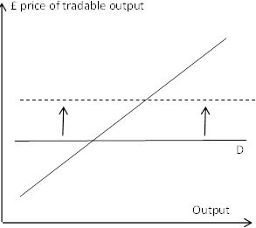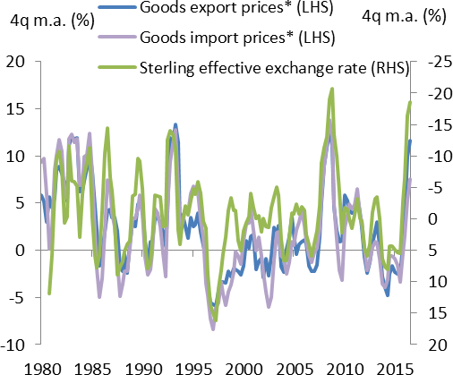Chart 6 gives a stylised description. In a competitive market the demand curve facing an individual firm (and those in a relatively small country) is essentially flat. Domestic events don’t have much effect on the global price. When the currency falls, pushing up prices and profits of outward-facing firms, the response of export volumes depends on the slope of the supply curve: to what extent do firms in the tradable sector have the capacity to raise output and, where that is insufficient, the willingness to invest in more?

|  |  |
| --- | --- |
| **Chart 6: For a small open economy tradable demand is highly elastic** | **Chart 7: Depreciations push up the sterling price of goods exports as well as those of imports** |
|  | Source: ONS and Thomson Reuters Datastream.  * excluding oil and erratics. |

Now commodities may be an extreme case. They’re essentially homogenous – one country’s output is much like another’s. But even in non-commodity goods markets you find a similar pattern. The UK is relatively small, accounting for only 3% of international goods trade (even including oil). Many UK firms are to a significant extent “price takers” in international markets. And you can see from Chart 7 the close correlation between the sterling price of the UK’s (non-oil) goods exports and the exchange rate. The reaction is a bit less than one-for-one but in general no less marked than that of import prices. That’s true of the most recent period as well: prices of non-oil goods exports rose 12% through the course of last year, in line with those of imports.

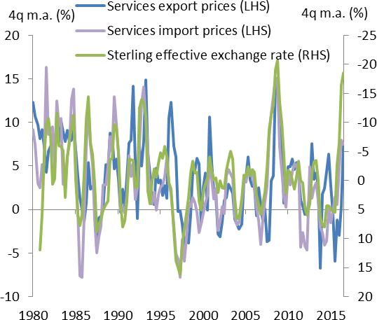Admittedly, the behaviour of the sterling price of services exports is rather different. They’re more stable in the face of exchange-rate movements (Chart 8), implying that depreciations do indeed reduce them in foreign currency terms. I think this is understandable. Services are less homogenous than goods and there’s more room for non-price competition. The UK has a larger presence in this area, accounting for 7% of global services trade in total, 12% for business and financial services specifically. Those wholesale services are relatively specialised.

|  |  |
| --- | --- |
| **Chart 8: Sterling price of services exports more stable** | Equally, and for many of the same reasons, the evidence suggests that service export volumes are much less sensitive to any cross-country variations in prices than in goods markets. Indeed it’s only because of this relative insensitivity that such variations can persist for any length of time.  At any rate, my main point here is that the positive effects of a currency depreciation depend at least as much on the response of domestic firms as on that of foreign buyers. If firms in the tradable sector have plenty of spare capacity you’d expect net export volumes to rise significantly; once capacity constraints start to bind you’d expect greater investment; in general, given that the degree of spare capacity is bound to vary across firms, you’d expect  to see both. |
| Source: ONS and Thomson Reuters Datastream |

I think this is what you have seen in the past – in both directions. The data are limited. Detailed sectoral numbers on profits and investment exist only from the early 1990s and until 2014. But that period does at least cover two significant moves in the currency, even before the financial crisis: the big drop when sterling fell out of the European Exchange Rate System (ERM) in 1992, after which the exchange rate remained relatively low for a few years; and the equally large re-appreciation in 1997 and 1998.

As it happens, I think these swings can be traced back to the demand-side influences I discussed in the last section. Subdued domestic consumption, public as well as private, supressed the exchange rate in the years after sterling exited the ERM; much stronger growth, associated in part with the revival in the housing market, helped to push it back up later that decade (you can see these broad movements back in Chart 3). And if you define the “tradable” part of the economy as those sectors with above-average trade shares,

“non-tradables” the rest, they behaved broadly as you might expect. Aggregate profits recovered strongly in the early 1990s, as they tend to in the early stage of economic recoveries. But, thanks to a jump in the sterling price of their output, the rise was most marked for firms exposed to international trade (Chart 9).

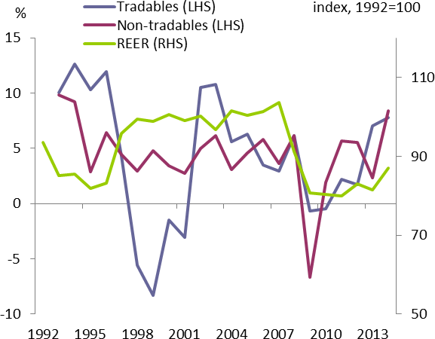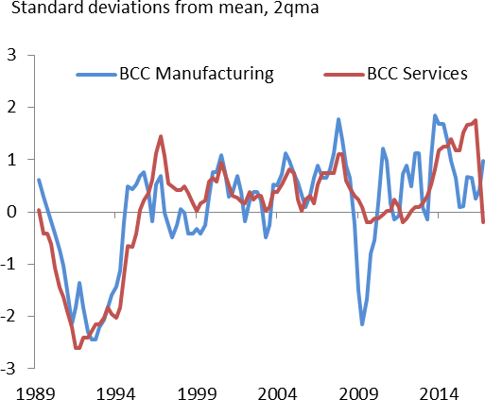There was plenty of slack in the economy (Chart 10 uses the balances on capacity use from the BCC surveys). Within the tradable sector in particular this allowed for a marked rise in net export volumes. In the three years after ERM exit the UK’s trade balance improved by close to 2% of GDP. Furthermore, despite that spare capacity, business investment too began to accelerate – and again it was the tradable sector whose spending grew fastest (Chart 11).

|  |  |
| --- | --- |
| **Chart 9: Profits in tradable sector boosted by depreciation in early 90s, hit by later appreciation** | **Chart 10: Unlike early 1990s, there is now limited spare capacity, including in tradable sector** |
| Source: ONS and Bank of England calculations | Source: BCC and Bank of England calculations |

|  |  |
| --- | --- |
| **Chart 11: Investment in tradable sector also sensitive to exchange rate** | **Chart 12: Business investment growth weak in 2016** |
| Source: ONS and Bank of England calculations | Source: ONS, CBI, BCC and CIPS |

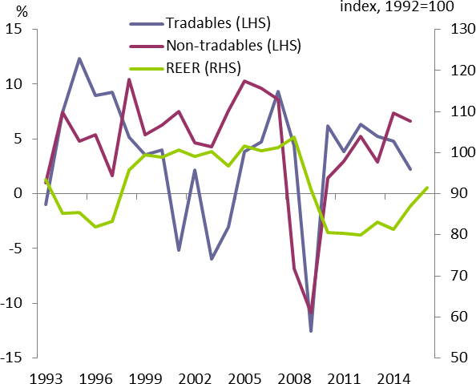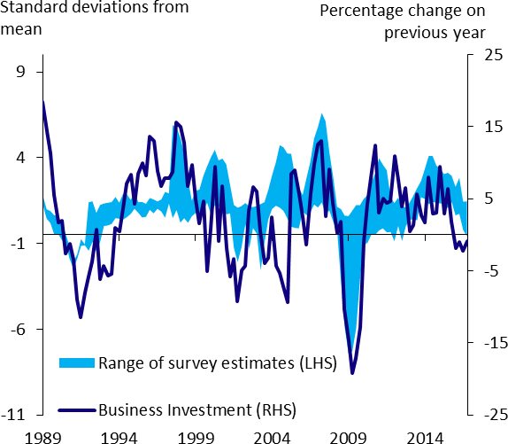These trends then went into reverse after sterling’s re-appreciation later than decade. If subdued domestic consumption had allowed the economy to “rebalance” through the 1992-97 period, the opposite occurred over the following few years. Stronger domestic demand growth “crowded out” the tradable sector by helping to push up sterling’s exchange rate. This led to falls in prices, profits and investment in the tradable sector.

What about today? Sadly we don’t have such detailed information on anything like a real-time basis. Indeed we have very little data of any kind, even at an aggregate level, to tell us how profits and investment have behaved since last summer. But here’s my take on what we do know:

* First, it’s likely that profitability has improved significantly in the tradable sector of the economy. We know that non-financial corporate profits in aggregate rose 10% in the year to Q3. We know too that export prices rose strongly last year, much faster than those of domestic-facing firms11. At a rough guess, and relative to that in the non-traded sector, this will have pushed up the rate of return in the traded sector by 2-3 percentage points12.
* Second – and this is in sharp contrast to the early 1990s – there is only limited spare capacity in the economy, including in its more tradable sectors (Chart 10 again). One would certainly expect net export volumes to improve this year. But one would also expect a greater share of the response to the depreciation, compared with the early 1990s, to come via stronger investment, less of it from

1. While export prices rose 12% in the year to 2016Q4, gross output prices across the economy as a whole, excluding the government sector, rose by around 4½% (by gross I mean including the cost of imports). With exports worth around one quarter of gross output, this would imply output-price inflation in the rest of the economy of less than 2%.
2. Higher prices boost profits, and disproportionately so, given the operational gearing. On the other hand exporting firms will also be

paying more for their imports, on which they rely more than others. To work out the overall impact on profits you need to net out the extra cost of imports. We’ve done this by passing the rise in both export and import prices through the UK’s input:output tables and used the same definition of tradables and non-tradables as before.

higher output in the tradable sector. There is less room to raise output but more of an incentive to add to that capacity.

* + Third, and despite these incentives, growth of overall business investment in the UK was relatively weak last year. Early official estimates say it shrank slightly in the year to Q4, by around 1%. (This compares with positive growth of 2% or so in the Euro area.) And although those estimates are particularly prone to revision, the various survey indicators also subsided in 2016 (Chart 12).

This last point is the critical one. The world economy is looking better than it has done for some time. Against this backdrop, and given the existing capacity constraints, the fall in sterling provides a powerful incentive to invest in the UK’s tradable sector. All else equal, it would make sense for existing exporters to expand; for domestic-facing firms to think about entering new markets; and for multinationals to shift production to the UK.

Yet some caution would also be understandable. All else is not equal. While much is at stake, no-one can be sure about the eventual outcome of the Brexit negotiations. The evidence suggests that investment is less responsive to these commercial incentives the greater the degree of uncertainty about future returns13. Nor is it just a matter of uncertainty: it’s unlikely that these propitious conditions will last forever. Either the currency market is right about the consequences of Brexit, in which case the UK’s trading relationships will become less favourable; or it’s wrong, in which case sterling is likely to recover. Yet even in normal times, currency moves generally have to endure for quite a while before multinationals decide to shift production from one location to another14.

So these are not straightforward decisions. Put simply, firms in the tradable sector, and those thinking of entering it, will be weighing the boost in the current rate of return against any additional risk premium they currently require of such investments. The question is whether the first is big enough to compensate for the second.

# Summary and conclusion

The adjective “post-Brexit” is bandied around quite a bit these days. The term’s a bit previous. A better description of the UK’s current economic circumstances is “post-referendum” but “pre-Brexit”.

The result is something of a sweet spot for exporters. Sterling fell sharply after the referendum and, despite the strength of consumption since then, has remained close to record lows. The most likely explanation is that the foreign exchange market believes that, when it does actually occur, leaving the EU will raise costs in

1. Bloom et al (2007); for more on the impact of uncertainty on sunk-cost investment decisions see Dixit and Pindyck (1994); Handly and Limao (2013) consider the specific case of uncertainty about tariffs.
2. For example Goldberg (2007).

the UK’s tradable sector. Whether this occurs through explicit tariffs, non-tariff barriers or lower productivity growth, the currency would need to be weaker in compensation.

But the UK’s trading rules are for the time being unchanged. The result is that the costs and ease of exporting are unchanged but the returns to it significantly higher. With the world economy looking better than for some time the circumstances for the tradable sector could hardly be more propitious. One would expect firms in the more open parts of the economy both to use up any spare capacity and, in the normal course of events, to invest significantly more in that capacity as well. Over the longer run, this reallocation of resources is what the positive impact of an exchange-rate depreciation relies upon.

It’s possible, of course, that Brexit won’t be as bad as the foreign exchange market appears to believe. If the government succeeds in negotiating a “new, comprehensive, bold and ambitious free trade agreement15” with the EU, and in opening up trade with non-European countries, the UK’s overall degree of openness may not worsen and it could improve. If so, and all else equal, the currency should in time rebound.

But this makes longer-term investment in the tradable sector a somewhat tricky decision. Either the currency market is too pessimistic, in which case sterling’s depreciation is likely to be reversed over time. Or it’s not, in which case the costs of exporting will eventually go up. Barring some other source of exchange rate weakness, such as a sharp rise in the household saving rate (which would have its own implications for the economy), the sweet spot is unlikely to last indefinitely. So while investments with shorter-term payoffs make commercial sense, especially for those already running up against capacity constraints, the uncertainties involved in longer-term decisions could temper the usually positive response of business spending to depreciations in the exchange rate. Indeed they’re probably already doing so somewhat.

In its latest forecasts the MPC expects this caution to persist. That’s why, in the central projection in the February Inflation Report, growth slows slightly this year, from 2.0% at the end of last year to 1.7% by 2017Q4. Though there are plenty of other variables to consider, the negative effects of the depreciation on consumption (via import prices and household income) are expected marginally to outweigh its more positive effects on other parts of demand.

If only implicitly the consensus forecast seems to attach more weight to this Brexit-related caution. My guess is that financial markets do so as well. Despite higher profitability, business investment is projected to stagnate or fall this year even as it accelerates significantly further in other developed economies. The more negative effects on consumption clearly predominate and growth of aggregate demand is projected to slow reasonably sharply, to 1.2% by the end of this year.

15 This is the Prime Minister’s phrasing in her [speech](https://www.gov.uk/government/speeches/the-governments-negotiating-objectives-for-exiting-the-eu-pm-speech) on 17 January.

Yet there are clearly risks to both. If businesses share the view of financial markets, and in particular the foreign exchange market, the risks around EU exit could persuade them to cut investment further this year. If they side more with consumers – who, as we’ve noted before, appear to have taken such uncertainties very much in their stride – they will respond more to today’s favourable conditions than to any caution about the longer-term future and instead raise investment spending.

**References**

**Bloom N., Bond S. and J. Reenen, 2007,** ‘Uncertainty and investment dynamics’ *The Review of Economic Studies*, 74 (2), pages 391-415

**Dixit A. and R. Pindyck, 1994**, ‘Investment under Uncertainty’, Princeton University Press

**Egert B., Halpern L. and R MacDonald, 2006,** ‘Equilibrium Exchange Rates in Transition Economies: Taking Stock of the Issues’, *Journal of Economic Surveys*

**Goldberg L., 2007,** ‘Exchnage rates and Foreign Direct Investment’, *Princeton Encyclopaedia of the World Economy*, Princeton University Press

**Handly K. and N. Limao, 2013,** ‘Policy uncertainty, trade and welfare: theory and evidence for China and the U.S.’, *NBER working paper No. 19376*

**Obstfeld M. and K. Rogoff, 2000,** [‘Perspectives on OECD economic integration : implications for U.S.](https://ideas.repec.org/a/fip/fedkpr/y2000p169-208.html) [current account adjustment](https://ideas.repec.org/a/fip/fedkpr/y2000p169-208.html),’ [*Proceedings - Economic Policy Symposium - Jackson Hole,*](https://ideas.repec.org/s/fip/fedkpr.html) *Federal Reserve Bank of Kansas City*, pages 169-208

**Obstfeld M. and K. Rogoff, 2007, ‘**The unsustainable US current account position revisited’, *published in G7 Current Account Imbalances, National Bureau of Economic Research*

**Samuelson Paul A., 1964,** ‘Theoretical notes on trade problems’, *Review of Economics and Statistics, Vol. 46*, pp. 145-54.